**VEER NARMAD SOUTH GUJARAT UNIVERSITY, SURAT**

**Second Year**

**Bachelor of Computer Application (S.Y.B.C.A.)**

**Semester – IV**



**Vimal Tormal Poddar BCA College Pandesara,Surat.**

**File Submission**

**404: Practical of VB.NET**

**YEAR : 2021-22**

**Submitted by : Gouda suraj**

**Roll No : 102**

**Div:- B**

**Exam No: 2019038887**

**Submitted To Mr. Prashant Ghantiwala**

**INDEX**

**Name: Gouda suraj**

**Class: SYBCA (SEM-4) Div.: B Roll No. 102 Exam Seat No. 2019038887**

**Subject : 406 – VB.NET PRACTICAL FILE Academic Year : 2021-22**

| **Sr. No** | **Program Defination** | **Page No.** | **Signature** |
| --- | --- | --- | --- |
| 1. | **MDI form** | 3 |  |
| 2. | **Display Hello Name** | 4 |  |
| 3. | **Show Name in Texbox** | 5 |  |
| 4. | **Number is Even or Odd.** | 6 |  |
| 5. | **Simple Calculator to with +, -, X, /** | 7 |  |
| 6 | **Students Marks, Per(%), Grade** | 8 |  |
| 7 | **Pass by Reference Concept.** | 9 |  |
| 8 | **Reverse String** | 11 |  |
| 9 | **String Functions.** | 12 |  |
| 10 | **Date and Time Functions.** | 14 |  |
| 11 | **Database(Insert, Update, Delete, Search)** | 15 |  |

**1. Create a MDI form and All the following windows(Programs) form should be open from MDI Menu click**

**Code:-**

PublicClassWindosfrm

PrivateSubSUMToolStripMenuItem_Click(ByVal sender AsSystem.Object, ByVal e AsSystem.EventArgs) HandlesSUMToolStripMenuItem.Click

btnCallSub.MdiParent = Me

btnCallSub.Show()

EndSub

PrivateSubREDIOBUTTONToolStripMenuItem_Click(ByVal sender AsSystem.Object, ByVal e AsSystem.EventArgs) HandlesREDIOBUTTONToolStripMenuItem.Click

rediobtn.MdiParent = Me

rediobtn.Show()

EndSub

PrivateSubCEHCKBOXToolStripMenuItem_Click(ByVal sender AsSystem.Object, ByVal e AsSystem.EventArgs) HandlesCEHCKBOXToolStripMenuItem.Click

checkbox.MdiParent = Me

checkbox.Show()

EndSub

PrivateSubCOMBOBOXToolStripMenuItem_Click(ByVal sender AsSystem.Object, ByVal e AsSystem.EventArgs) HandlesCOMBOBOXToolStripMenuItem.Click

COMBOBOXDEMO.MdiParent = Me

COMBOBOXDEMO.Show()

EndSub

PrivateSubENUMToolStripMenuItem_Click(ByVal sender AsSystem.Object, ByVal e AsSystem.EventArgs) HandlesENUMToolStripMenuItem.Click

frmEnum.MdiParent = Me

frmEnum.Show()

EndSub

PrivateSubSTRINGDATEFUNCATIONToolStripMenuItem_Click(ByVal sender AsSystem.Object, ByVal e AsSystem.EventArgs) HandlesSTRINGDATEFUNCATIONToolStripMenuItem.Click

frmStringFuncation.MdiParent = Me

frmStringFuncation.Show()

EndSub

PrivateSubDATEFUNCATIONToolStripMenuItem_Click(ByVal sender AsSystem.Object, ByVal e AsSystem.EventArgs) HandlesDATEFUNCATIONToolStripMenuItem.Click

frmDateFuncatiom.MdiParent = Me

frmDateFuncatiom.Show()

EndSub

PrivateSubIFSTATEMENTToolStripMenuItem_Click(ByVal sender AsSystem.Object, ByVal e AsSystem.EventArgs) HandlesIFSTATEMENTToolStripMenuItem.Click

btnSwitchCase.MdiParent = Me

btnSwitchCase.Show()

EndSub

EndClass

**Output:-**

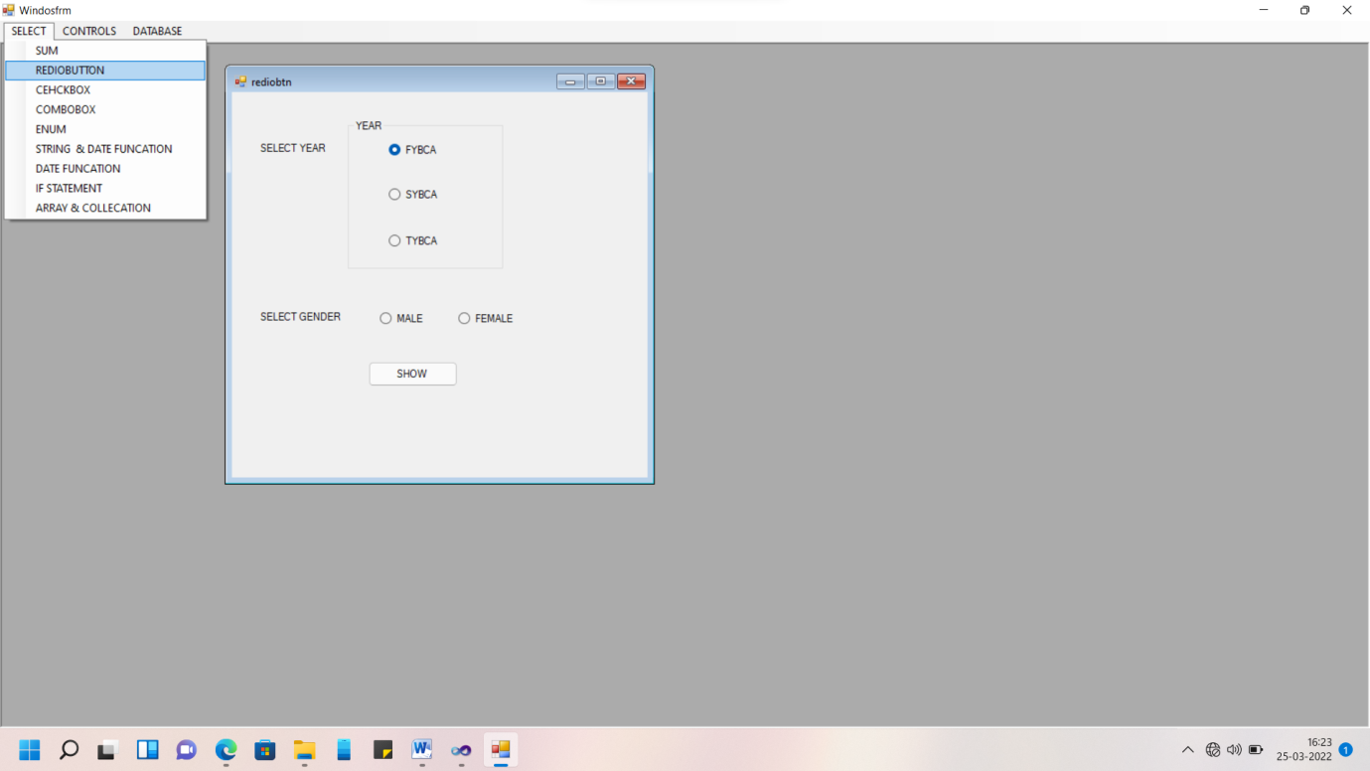

**2. Enter your name in a textbox and display hello name in second textbox after clicking a button.**

**Code:-**

PublicClassfrmAddName

PrivateSub Button1_Click(ByVal sender AsSystem.Object, ByVal e AsSystem.EventArgs) Handles Button1.Click

txt2.Text = ("Hello " + txt1.Text)

EndSub

EndClass

**Output:-**

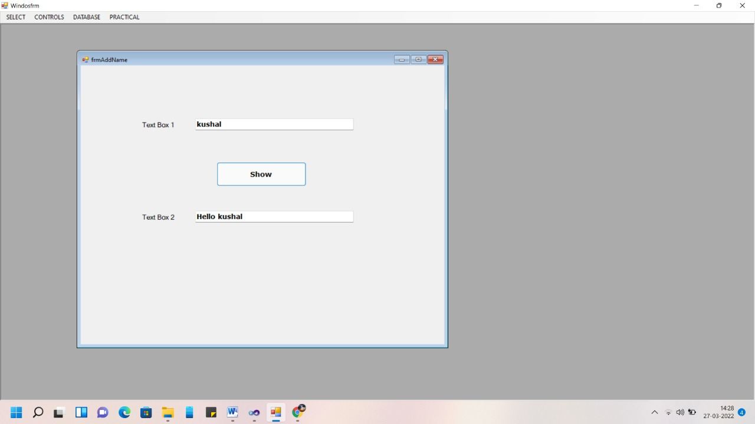

**3. Enter your name in a textbox and it will show name enter by you on another textbox in Upper case.**

**Code:-**

PublicClassfrmUpperCase

PrivateSub Button1_Click(ByVal sender AsSystem.Object, ByVal e AsSystem.EventArgs) Handles Button1.Click

txt2.Text = UCase(txt1.Text)

EndSub

EndClass

**Output:-**

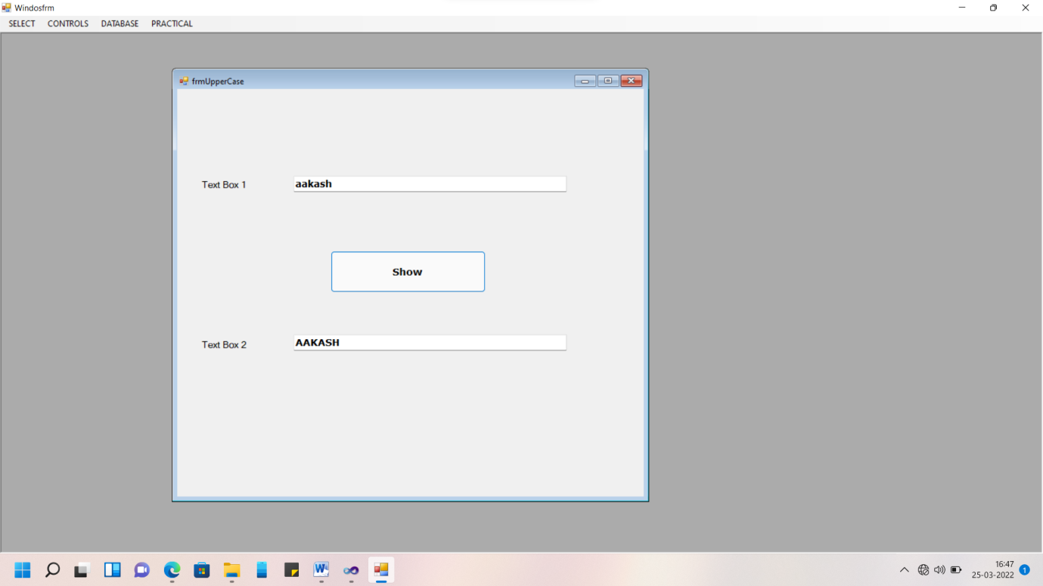

**4. Enter number in the textbox and display that number is even or odd.**

**Code:-**

PublicClassfrmeven

PrivateSubbtnRes_Click(ByVal sender AsSystem.Object, ByVal e AsSystem.EventArgs) HandlesbtnRes.Click

Iftxtno.TextMod 2 = 0 Then

lblRes.Text = "Number is Even Number"

Else

lblRes.Text = "Number is Odd Number"

EndIf

EndSub

EndClass

**Output:-**

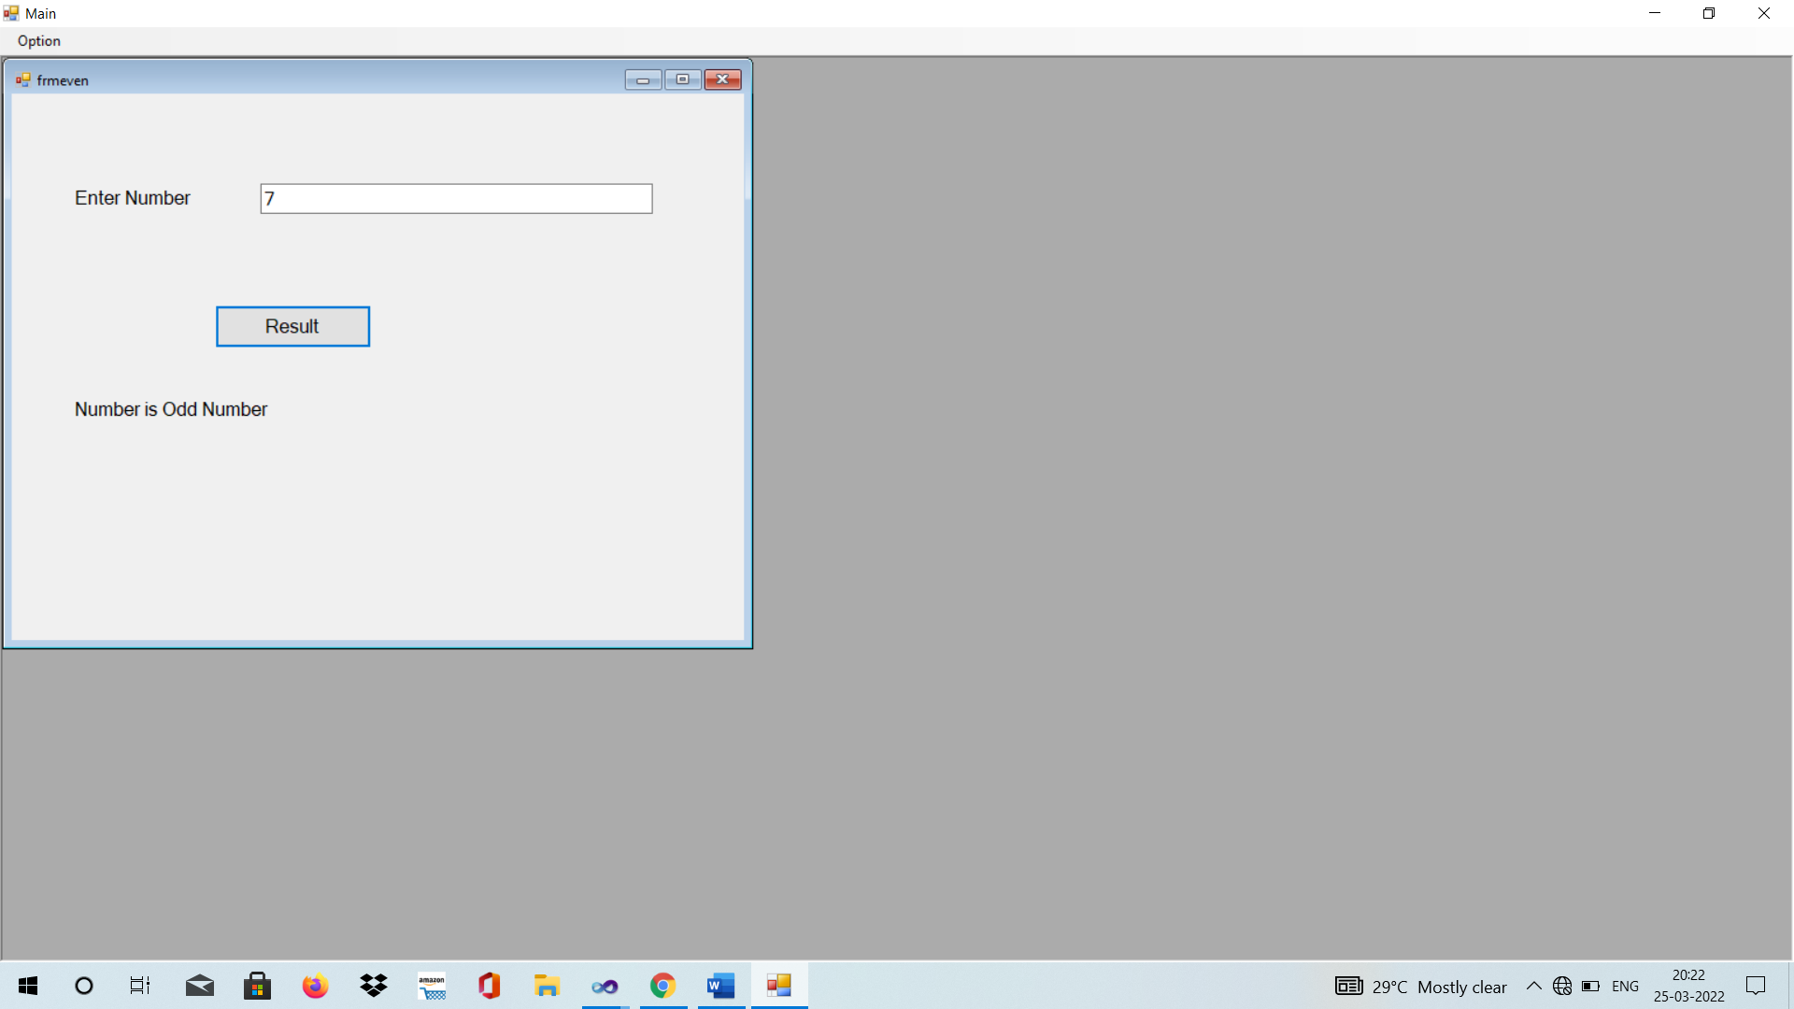

**5. Create simple calculator to with +, -, X, / functionality.**

**Code:-**

PublicClassfrmCalculator

PrivateSub Button3_Click(ByVal sender AsSystem.Object, ByVal e AsSystem.EventArgs) Handles Button3.Click

txtans.Text = Val(txtno1.Text) - Val(txtno2.Text)

EndSub

PrivateSub Button1_Click(ByVal sender AsSystem.Object, ByVal e AsSystem.EventArgs) Handles Button1.Click

txtans.Text = Val(txtno1.Text) + Val(txtno2.Text)

EndSub

PrivateSub Button4_Click(ByVal sender AsSystem.Object, ByVal e AsSystem.EventArgs) Handles Button4.Click

txtans.Text = Val(txtno1.Text) * Val(txtno2.Text)

EndSub

PrivateSub Button2_Click(ByVal sender AsSystem.Object, ByVal e AsSystem.EventArgs) Handles Button2.Click

txtans.Text = Val(txtno1.Text) / Val(txtno2.Text)

EndSub

EndClass

**Output:-**

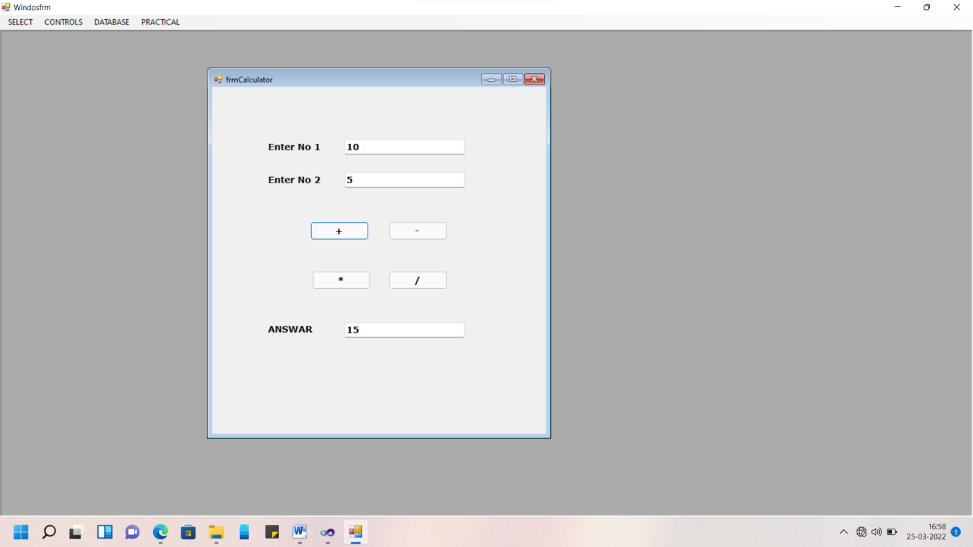

**6. Enter student’s marks out of 100 in 5 different textboxes and add them on button click and display the percentage on label control. Check if Percentage < 49 then give massage fail, percentage from 50 to 60 then give massage Second class, Percentage from 61 to 69 then give massage first Class, Percentage >= 70 then give massage Distinction class using If…Else If**

**Code:-**

PublicClassfrmMarks

PrivateSubbtnRes_Click(ByVal sender AsSystem.Object, ByVal e AsSystem.EventArgs) HandlesbtnRes.Click

lblTotal.Text = Val(txt1.Text) + Val(txt2.Text) + Val(txt3.Text) + Val(txt4.Text) + Val(txt5.Text)

lblPer.Text = Val(lblTotal.Text) / 5

EndSub

PrivateSubbtnGrade_Click(ByVal sender AsSystem.Object, ByVal e AsSystem.EventArgs) HandlesbtnGrade.Click

IflblPer.Text>= 70 Then

lblGrade.Text = "Distinction class"

ElseIflblPer.Text>= 60 Then

lblGrade.Text = "First Class"

ElseIflblPer.Text>= 50 Then

lblGrade.Text = "Second Class"

Else

lblGrade.Text = "Fail"

EndIf

EndSub

EndClass

**Output:-**

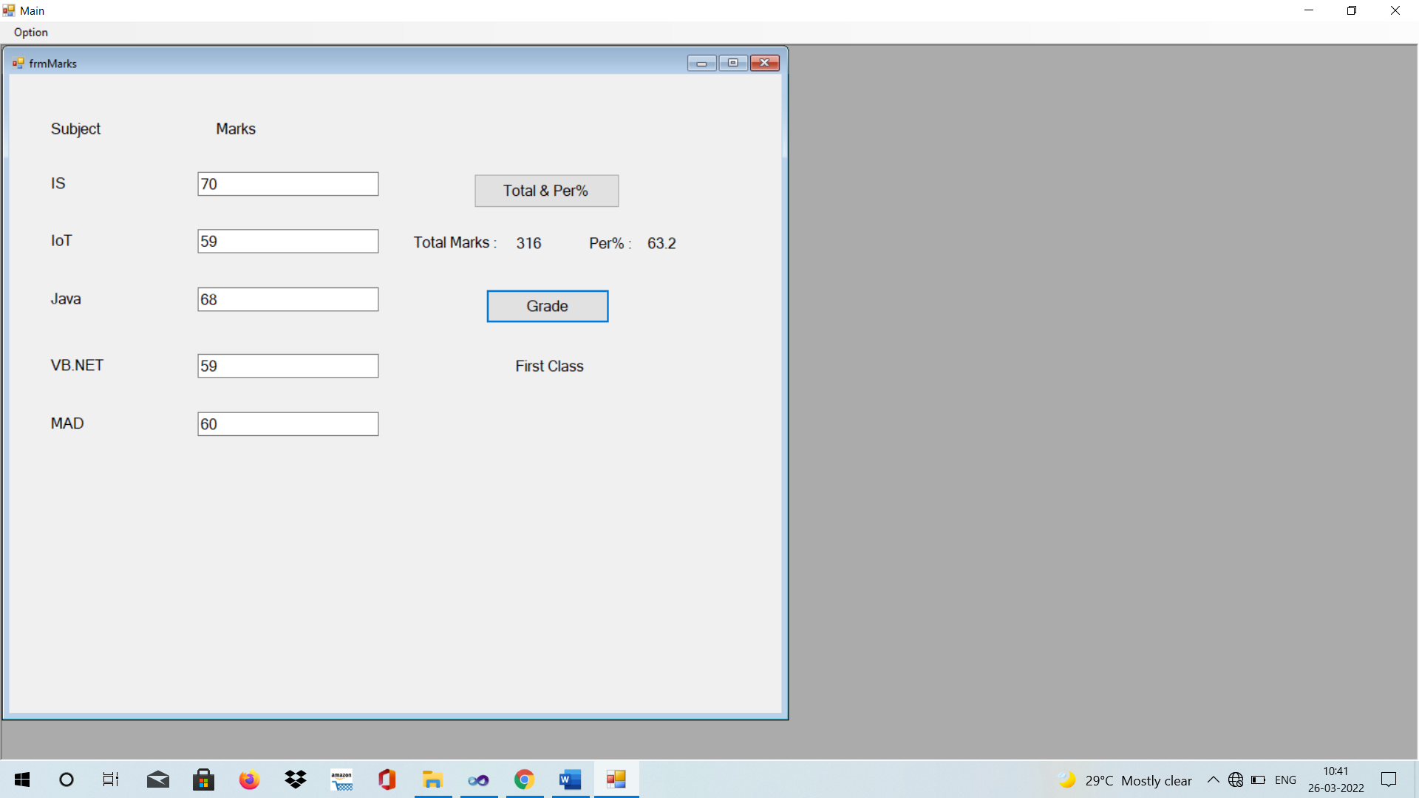

**7. Write a code to explain use of pass by reference concept.**

**Code:-**

PublicClassfrmCallbyref

PrivateFunction Add2No_byRef(ByRef no1 AsInt16, ByRef no2 AsInt16) AsLong

no1 = no1 + 2

no2 = no2 + 2

Return no1 + no2

EndFunction

PrivateSubbtnCallbyRef_Click(ByVal sender AsSystem.Object, ByVal e AsSystem.EventArgs) HandlesbtnCallbyRef.Click

Dim a AsInt16, b, c AsInt16

a = Val(txtno1.Text)

b = Val(txtno2.Text)

c = 2

txtans.Text = Add2No_byRef(a, b) ' Call by Reference

txt_a.Text = a

txt_b.Text = b

EndSub

PrivateFunctionAdd2No(ByVal no1 AsInt16, ByVal no2 AsInt16) AsLong

no1 = no1 + 2

no2 = no2 + 2

Return no1 + no2

EndFunction

PrivateSubbtnsum_Click(ByVal sender AsSystem.Object, ByVal e AsSystem.EventArgs) Handlesbtnsum.Click

Dim a AsInt16, b AsInt16

a = Val(txtno1.Text)

b = Val(txtno2.Text)

txtans.Text = Add2No(a, b) ' Call by value

txt_a.Text = a

txt_b.Text = b

EndSub

EndClass

**Output:-**

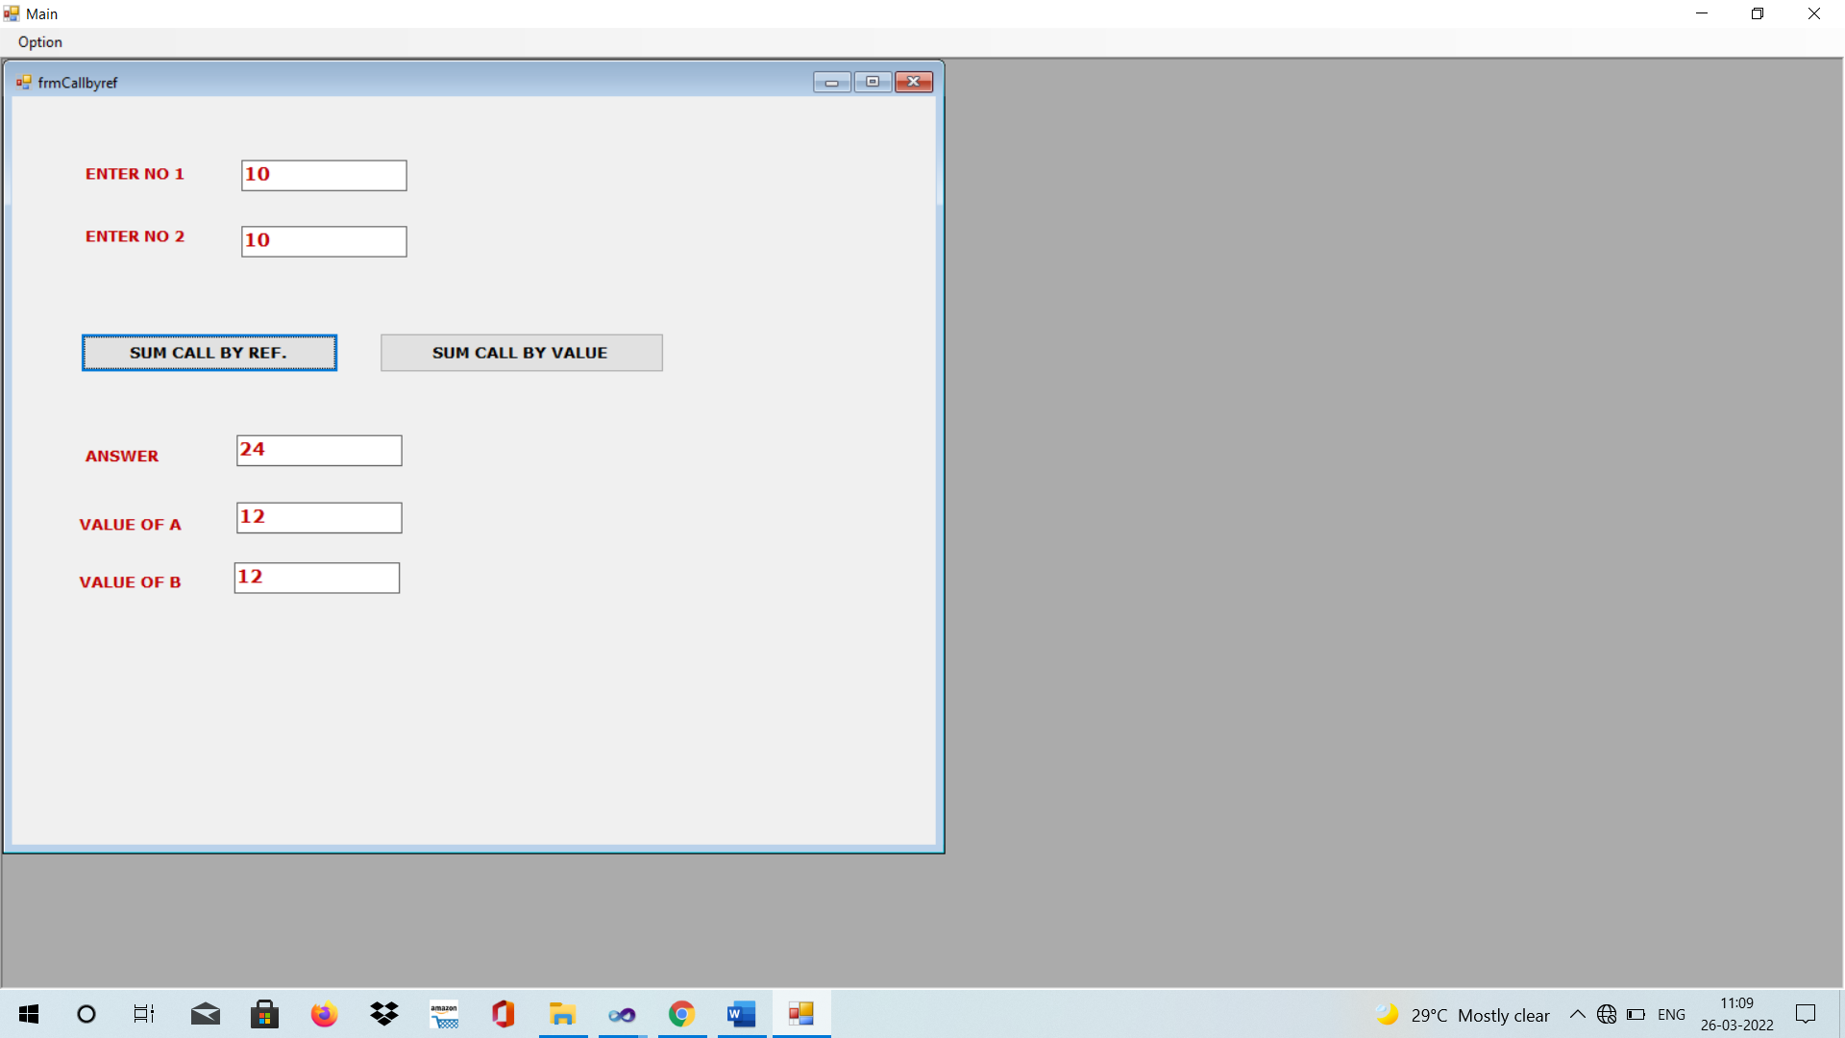

**8. Enter your name in textbox and should be display in reverse order on another textbox.**

**Code:-**

PublicClassfrmReverse

PrivateSubbtnRev_Click(ByVal sender AsSystem.Object, ByVal e AsSystem.EventArgs) HandlesbtnRev.Click

txtRev.Text = StrReverse(txtStr.Text)

EndSub

EndClass

**Output:-**

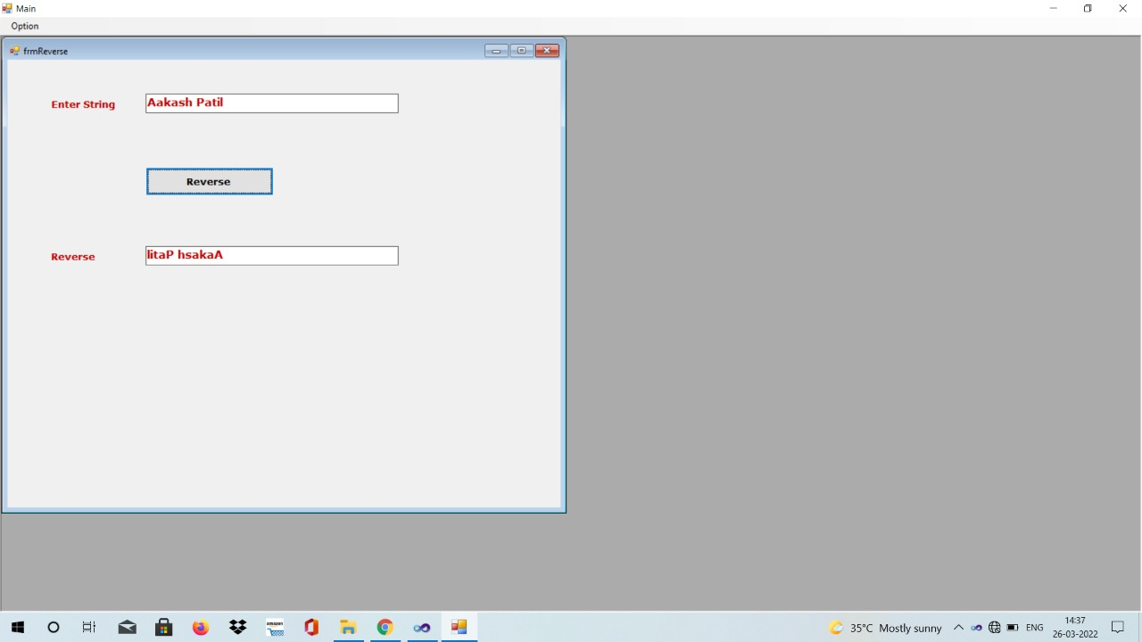

**9. Create a windows form for demonstrate the all string functions.**

**Code:-**

PublicClassfrmStringFuncation

'VIMAL TORMAL PODDAR BCA COLLEGE

'Tpye of String Funcation in vb.net

'LEFT 'RIGHT 'MID 'INSTR 'LEN 'LCASE 'UCASE 'LTRIM 'RTRIM 'TRIM 'REPLACE

PrivateSubbtnLeft_Click(ByVal sender AsSystem.Object, ByVal e AsSystem.EventArgs) HandlesbtnLeft.Click

txtResult.Text = Microsoft.VisualBasic.Left(txtdata.Text, 5)

EndSub

PrivateSubbtnRigth_Click(ByVal sender AsSystem.Object, ByVal e AsSystem.EventArgs) HandlesbtnRigth.Click

txtResult.Text = Microsoft.VisualBasic.Right(txtdata.Text, 5)

EndSub

PrivateSubbtnMid_Click(ByVal sender AsSystem.Object, ByVal e AsSystem.EventArgs) HandlesbtnMid.Click

txtResult.Text = Mid(txtdata.Text, 3, 7)

EndSub

PrivateSubbtnInstr_Click(ByVal sender AsSystem.Object, ByVal e AsSystem.EventArgs) HandlesbtnInstr.Click

txtResult.Text = InStr(txtdata.Text, "BCA", CompareMethod.Text) EndSub

PrivateSubbtnLen_Click(ByVal sender AsSystem.Object, ByVal e AsSystem.EventArgs) HandlesbtnLen.Click

txtResult.Text = txtdata.Text.Length

EndSub

PrivateSubbtnUcase_Click(ByVal sender AsSystem.Object, ByVal e AsSystem.EventArgs) HandlesbtnUcase.Click

txtResult.Text = UCase(txtdata.Text)

'txtResult.Text = txtdata.Text.ToUpper

EndSub

PrivateSubbtnLcase_Click(ByVal sender AsSystem.Object, ByVal e AsSystem.EventArgs) HandlesbtnLcase.Click

txtResult.Text = LCase(txtdata.Text)

'txtResult.Text = txtdata.Text.ToLower

EndSub

PrivateSubbtnLtrim_Click(ByVal sender AsSystem.Object, ByVal e AsSystem.EventArgs) HandlesbtnLtrim.Click

txtResult.Text = LTrim(txtdata.Text) 'Remove Blank space from left side

EndSub

PrivateSubbtnRtrim_Click(ByVal sender AsSystem.Object, ByVal e AsSystem.EventArgs) HandlesbtnRtrim.Click

txtResult.Text = RTrim(txtdata.Text) 'Remove Blank space from right side

EndSub

PrivateSubbtnTrim_Click(ByVal sender AsSystem.Object, ByVal e AsSystem.EventArgs) HandlesbtnTrim.Click

txtResult.Text = Trim(txtdata.Text) 'Remove Blank space from both side

EndSub

PrivateSubbtnReplace_Click(ByVal sender AsSystem.Object, ByVal e AsSystem.EventArgs) HandlesbtnReplace.Click

txtResult.Text = Replace(txtdata.Text, "BCA", "MCA", 1, -1, CompareMethod.Text)

EndSub

EndClass

**Output:-**

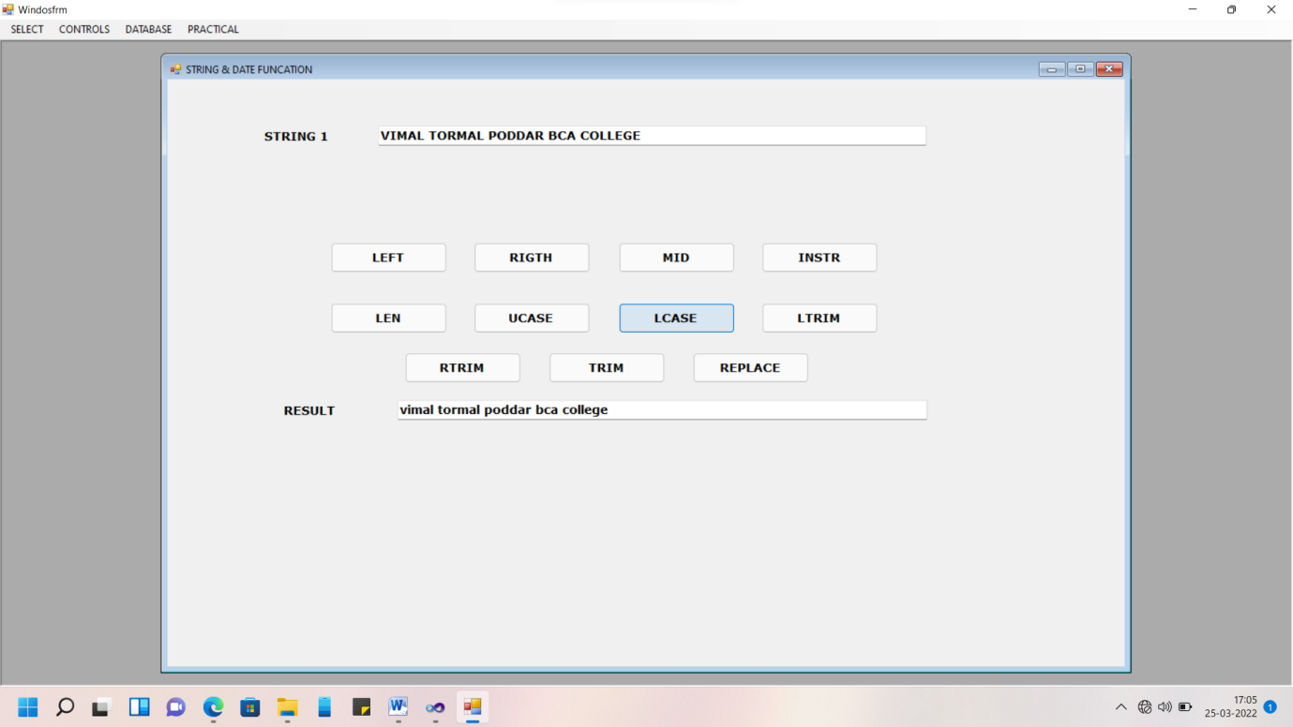

**10.Create a windows form for demonstrate the all Date and Time functions.**

**Code:-**

PublicClassfrmDateTime

PrivateSubbtnShow_Click(ByVal sender AsSystem.Object, ByVal e AsSystem.EventArgs) HandlesbtnShow.Click

txtResult.Text = Format(dtp1.Value, "dd/MM/yyyy")

txtTime.Text = Format(dtp2.Value, "hh:mm:ss")

EndSub

EndClass

**Output:-**

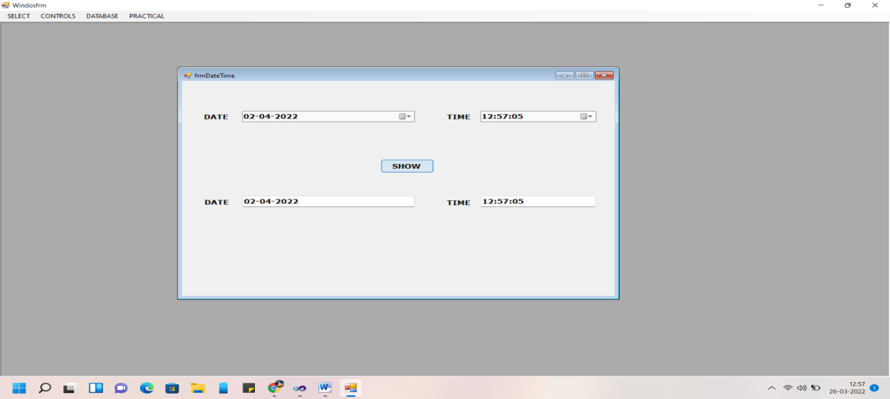

**11.Create a windows application that perform insert, Update, Delete and Searching on following Table. Table Name :Emp (EmpNo, Ename, MobileNo, Salary).**

**Code:-**

ImportsSystem.Data.SqlClient

ImportsSystem.Data

PublicClassfrmDatabaseEmp

DimconnectionStringAsString = "Data Source=.\SQLEXPRESS;AttachDbFilename=C:\aakash\vb.net\sum\sum\bin\Debug\Emp.mdf;Integrated Security=True;Connect Timeout=30;User Instance=True"

DimcnAsNewSqlConnection(connectionString)

PrivateSubfrmDatabaseEmp_Load(ByVal sender AsSystem.Object, ByVal e AsSystem.EventArgs) HandlesMyBase.Load

cn.Open()

Filldata()

EndSub

PrivateSubbtnShow_Click(ByVal sender AsSystem.Object, ByVal e AsSystem.EventArgs) HandlesbtnShow.Click

DimcmdAsNewSqlCommand

DimstrSQLAsString

'strSQL = "insert into emp values(1,'AJAY','6353051644',15000)"

strSQL = "insert into empvalues("&txtEmpNo.Text&",'"&txtName.Text&"','"&txtMobile.Text&"',"&txtSalary.Text&")"

Filldata()

cmd.CommandText = strSQL

cmd.Connection = cn

cmd.ExecuteNonQuery()

MsgBox("Record Saves Successfully")

cmd.Dispose() 'Cmd object will be removed from memroy

ClearFrom()

txtEmpNo.Focus()

EndSub

PrivateSubClearFrom()

txtEmpNo.Clear()

txtName.Clear()

txtMobile.Clear()

txtSalary.Clear()

EndSub

PrivateSubbtnGetRec_Click(ByVal sender AsSystem.Object, ByVal e AsSystem.EventArgs) HandlesbtnGetRec.Click

DimcmdAsNewSqlCommand

DimstrSQLAsString

DimdrAsSqlDataReader

Filldata()

'strSQL = "Select * from emp where empno=1"

strSQL = "Select * from Emp where EmpNo="& Val(txtEmpNo.Text) &""

cmd.CommandText = strSQL

cmd.Connection = cn

dr = cmd.ExecuteReader

Ifdr.HasRows = TrueThen

dr.Read() 'Move from BOF to first record (and next)

txtName.Text = dr.Item("EmpName").ToString

txtMobile.Text = dr.Item("MobileNo").ToString

txtSalary.Text = dr.Item("Salary").ToString

Else

MsgBox("No record found")

ClearFrom()

EndIf

dr.Close()

cmd.Dispose()

EndSub

PrivateSubbtnUpdate_Click(ByVal sender AsSystem.Object, ByVal e AsSystem.EventArgs) HandlesbtnUpdate.Click

DimcmdAsNewSqlCommand

DimstrSQLAsString

Filldata()

'strSQL = "insert into emp values(1,'AJAY','6353051644',15000)"

strSQL = "Update emp Set EmpName='"&txtName.Text&"',MobileNo='"&txtMobile.Text&"',Salary="& Val(txtSalary.Text) &"where EmpNo="& Val(txtEmpNo.Text) &""

cmd.CommandText = strSQL

cmd.Connection = cn

cmd.ExecuteNonQuery()

MsgBox("Record Updated Successfully")

cmd.Dispose() 'Cmd object will be removed from memroy

ClearFrom()

txtEmpNo.Focus()

EndSub

PrivateSubbtnDelete_Click(ByVal sender AsSystem.Object, ByVal e AsSystem.EventArgs) HandlesbtnDelete.Click

DimcmdAsNewSqlCommand

DimstrSQLAsString

Filldata()

'strSQL = "insert into emp values(1,'AJAY','6353051644',15000)"

IfMsgBox("Are you sure, want to delete", MsgBoxStyle.YesNo + vbDefaultButton2 + vbQuestion, "Delete Record") = vbYesThen

strSQL = "Delete from Emp where empno="&Val(txtEmpNo.Text) &""

EndIf

cmd.CommandText = strSQL

cmd.Connection = cn

cmd.ExecuteNonQuery()

MsgBox("Record Deleted Successfully")

cmd.Dispose() 'Cmd object will be removed from memroy

ClearFrom()

txtEmpNo.Focus()

EndSub

PrivateSubFilldata()

DimcmdAsNewSqlCommand

DimstrSQLAsString

Dim ds AsNewDataSet

Dim da AsNewSqlDataAdapter

strSQL = "select * from emp"

cmd.CommandText = strSQL

cmd.Connection = cn

da.SelectCommand = cmd

da.Fill(ds)

DataGridView1.DataSource = ds.Tables(0)

cmd.Dispose() 'Cmd object will be removed from memroy

ClearFrom()

txtEmpNo.Focus()

EndSub

EndClass

**Output:-**

